SENG 301 Project

Justin Chu

David Kenny

Contents

Introduction 4

Use Cases 4

Assumptions 4

Numbering System 4

Prototype 1 5

Instructions 5

Get a recommendation as a one time user 5

Create account 5

Keep Track of Watched Anime 6

Get a recommendation as a user with watched anime 6

States 7

Prototype 2 15

Instructions 15

Get a recommendation as a one time user 15

Create account 15

Keep Track of Watched Anime 16

Get a recommendation as a user with watched anime 16

States 17

Design Evaluation 26

Design Decisions 26

Prototype 1 Evaluation 26

Prototype 2 Evaluation 26

Prototype choice 26

# Introduction

This file demonstrates two low-fidelity prototypes that cover four use cases that make up the backbone of our project. This file also provides detailed instructions on how to achieve these tasks using each prototype presented. It also provides details about design decisions as well as chooses a prototype that will be used for the final product.

## Use Cases

As instructed, the use cases depicted by this file are the use cases that make up our backbone for the story map included within the second deliverable.

1. Get a recommendation as a one time user
2. Create account
3. Keep track of watched anime
4. Get a recommendation as a user with watched anime

## Assumptions

For use cases 1 and 2, it is assumed that the user is not currently logged into an account. For use cases 3 and 4, it is assumed that the user already has an account on the website and has just logged into their account.

## Numbering System

Each prototype will consist of numbered states starting at state 0. To indicate which prototype each state refers to, the numbered state will be prepended with either a 1 or a 2 followed by a period. For instance if the document is referring to state 3 for prototype 1, it will list it as state 1.3.

# Prototype 1

This prototype will demonstrate a website that can be run in any standard browser. Due to being a website, it also has the capabilities of performing any function the browser can perform.

## Instructions

This next subsection will provide clear and detailed instructions on how to perform each use case listed using prototype 1. The states indicated in this section can be found in the following section.

## Get a recommendation as a one-time user

To get a recommendation as a one-time user, please perform the following:

1. Proceed to (state 1.0). This state is the home screen of the website for users that are not logged in which will start with an empty textbox below “enter anime”. Type in an anime title into the textbox and click recommend.
   1. If the user types in an anime title that is not recognized:
      1. The system will display (state 1.1), indicating that the anime was not found through the appearance of a pop up.
      2. After the user clicks the okay prompt within the pop up, the system will display (state 1.0).
   2. If the user types in an anime title that is recognized:
      1. The system will display (state 1.2), listing various recommended anime and various details about the anime in a table format. The system will also display a home button which will return to state (1.0). It will also give the user the ability to filter the recommended anime by various filters like genre or year.

## Create account

To create an account, please do the following:

1. Proceed to (state 1.0). This state is the home screen of the website for users that are not logged in which will start with an empty textbox below “enter anime”. Click the sign up button.
2. When clicked, the system will display (state 1.3) with all textboxes empty. This state is the create account page which will display empty textboxes for a username, a password, a confirmation for password, and email fields.
   1. The user will fill in each of the fields
      1. If the user fills in each field correctly:
         1. The system will display (state 1.4) indicating that the account was created successfully
         2. After the user clicks the okay button, the system will display (state 1.6) which is the login screen.
      2. If the user tries to create an account using a username that is currently taken:
         1. The system will display (state 1.5), indicating that the username is currently taken
         2. After the user clicks the okay button, the system will display (state 1.3) again so the user can try to create an account again
      3. If the user tries to create an account but the passwords do not match for the password field and the confirm password field:
         1. The system will display (state 1.5), indicating that the passwords do not match
         2. After the user clicks the okay button, the system will display (state 1.3) again so the user can try to create an account again
      4. If the user tries to create an account but the email is not a valid form for an email:
         1. The system will display (state 1.5), indicating that the email is not valid.
         2. After the user clicks the okay button, the system will display (state 1.3) again so the user can try to create an account again.
      5. If the user tries to create an account but a field is not filled in:
         1. The system will display (state 1.5), indicating that one or more of the fields are not filled in.
         2. After the user clicks the okay button, the system will display (state 1.3) again so the user can try to create an account again

## Keep Track of Watched Anime

To keep track of watched anime, please do the following:

1. Proceed to (state 1.7). This state is the home screen for users that are logged into an account. It displays buttons that will navigate to the user’s watched anime list, import their watched anime list on Myanimelist.com (MAL), and recommend them anime based on their watched anime list. It will also have a logout button to log the user out of their account, and a home button which will take them back to (state 1.13). To access the watched anime list, click the button labeled “Watched anime”
2. When clicked, the system will display (state 1.8). This state will display the current list of watched anime in a table format that the user has on his/her account. It will also have buttons to take them back to the home screen for users (state 1.7), one to log the user out, one to allow them to get recommendations for single anime, and one to add anime to their watched anime list. To add anime, click the add button below the watched anime list.
3. When clicked, the system will display (state 1.9) with an empty textbox. The user will type in an anime title and click the add button.
   1. If the user types in an anime title that is not recognized:
      1. The system will display (state 1.10), indicating that the anime was not found through the appearance of a pop up.
      2. After the user clicks the okay prompt within the pop up, the system will display (state 1.9) so that the user can try again.
   2. If the user types in an anime title that is recognized:
      1. The system will display (state 1.11), indicating that the anime was successfully added.
      2. After the user clicks the okay prompt within the pop up, the system will display state (1.8) with the added anime now on the list of watched anime.

## Get a recommendation as a user with watched anime

To get a recommendation based on the user’s current watched anime list, please do the following:

1. Proceed to (state 1.7). This state is the home screen for users that are logged into an account. It displays buttons that will navigate to the user’s watched anime list, import their watched anime list on Myanimelist.com (MAL), and recommend them anime based on their watched anime list. It will also have a logout button to log the user out of their account, and a home button which will take the user to (state 1.13) and allow for a recommendation for a single anime. To get a recommendation based on the user’s watched anime list, click the button labeled “Get recommendations”
2. When clicked, the system will display (state 1.12) which will show the recommended anime in a table format with filters to the right. There will also be buttons to take the user back to the user home page (state 1.7), to log out, and to the home screen so they can get recommendations for single anime (state 1.13).

## States

Please find the states of the described prototype below. The states are in ascending order starting at state 1.0.

## 

State 1.0

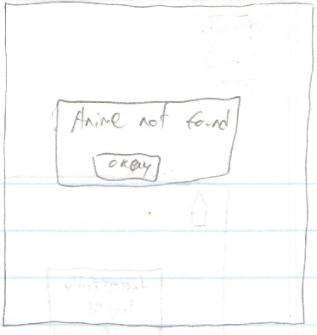

State 1.1

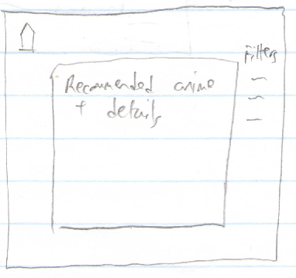

State 1.2

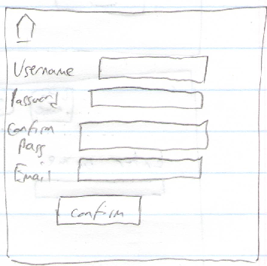

State 1.3

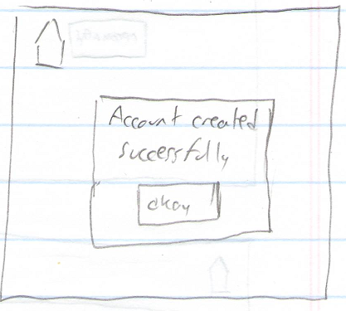

State 1.4

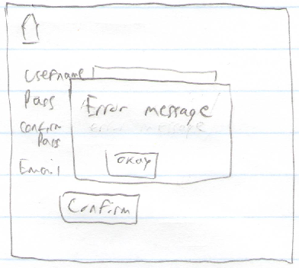

State 1.5

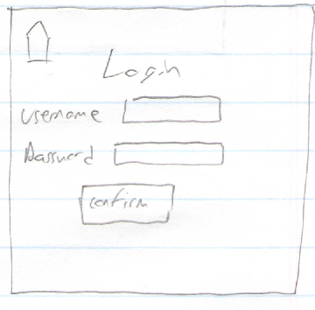

State 1.6

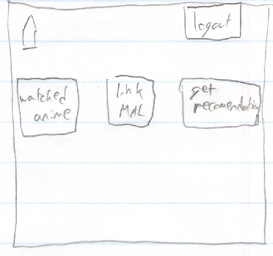

State 1.7

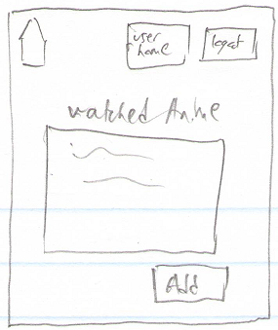

State 1.8

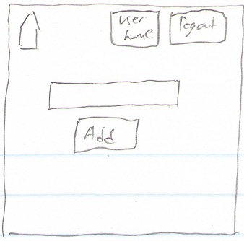

State 1.9

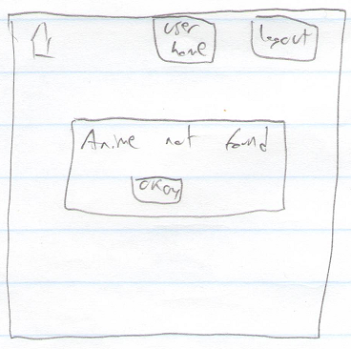

State 1.10

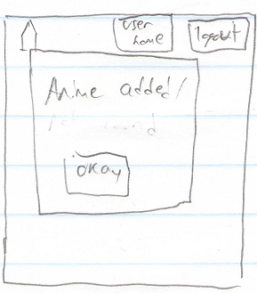

State 1.11

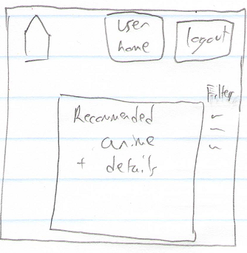

State 1.12

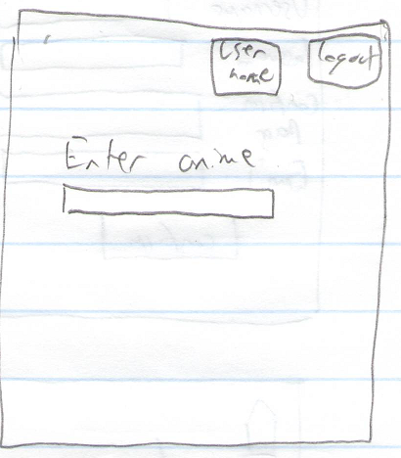

State 1.13

# Prototype 2

This prototype will demonstrate a website that can be run in any standard browser. Due to being a website, it also has the capabilities of performing any function the browser can perform.

## Instructions

This next subsection will provide clear and detailed instructions on how to perform each use case listed using prototype 2. The states indicated in this section can be found in the following section.

## Get a recommendation as a one-time user

To get a recommendation as a one-time user, please perform the following:

1. Proceed to (state 2.0). This state is the home screen of the website for users that are not logged in which will start with an empty textbox. Type in an anime title into the textbox and click recommend.
   1. If the user types in an anime title that is not recognized:
      1. The system will display (state 2.1), indicating that the anime was not found through the appearance of a pop up.
      2. After the user clicks the okay prompt within the pop up, the system will display (state 2.0).
   2. If the user types in an anime title that is recognized:
      1. The system will display (state 2.2), indicating various recommended anime and corresponding details (genre, year released, etc) in a table format. The system will also give the ability to filter the recommended anime by various filters like genre or studio.

## Create account

To create an account, please do the following:

1. Proceed to (state 2.0). This state is the home screen of the website for users that are not logged in. Click the create account button.
2. When clicked, the system will display (state 2.3) with all textboxes empty. This state is the create account page which will display empty textboxes for a username, a password, a confirmation for password, and email fields.
   1. The user will fill in each of the fields
      1. If the user fills in each field correctly:
         1. The system will display (state 2.4) indicating that the account was created successfully
         2. After the user clicks the okay button, the system will display (state 2.6) which is the login screen.
      2. If the user tries to create an account using a username that is currently taken:
         1. The system will display (state 2.5), indicating that the username is currently taken
         2. After the user clicks the okay button, the system will display (state 2.3) again so the user can try to create an account again
      3. If the user tries to create an account but the passwords do not match for the password field and the confirm password field:
         1. The system will display (state 2.5), indicating that the passwords do not match
         2. After the user clicks the okay button, the system will display (state 2.3) again so the user can try to create an account again
      4. If the user tries to create an account but the email is not a valid form for an email:
         1. The system will display (state 2.5), indicating that the email is not valid.
         2. After the user clicks the okay button, the system will display (state 2.3) again so the user can try to create an account again.
      5. If the user tries to create an account but a field is not filled in:
         1. The system will display (state 2.5), indicating that one or more of the fields are not filled in.
         2. After the user clicks the okay button, the system will display (state 2.3) again so the user can try to create an account again

## Keep Track of Watched Anime

To keep track of watched anime, please do the following:

1. Proceed to (state 2.7). This state is the home screen for logged in users which will display the current user’s list of watched anime in a table format. It will also display buttons that will allow the user to import their Myanimelist.com (MAL) account’s watched anime list, recommend anime based on their watched anime, as well as recommend anime based on a single watched anime. To add an anime to the watched list, type in the anime title and click the add button.
   1. If the user types in an anime title that is not recognized:
      1. The system will display (state 2.8), indicating that the anime was not found through the appearance of a pop up.
      2. After the user clicks the okay prompt within the pop up, the system will display (state 2.7) with no added anime.
   2. If the user types in an anime title that is recognized:
      1. The system will display (state 2.9), indicating that the anime was successfully added through the appearance of a pop up.
      2. After the user clicks the okay prompt within the pop up, the system will display (state 2.7) with the newly added anime.

## Get a recommendation as a user with watched anime

To get a recommendation based on the user’s current watched anime list, please do the following:

1. Proceed to (state 2.7). This state is the home screen for logged in users which will display the current user’s list of watched anime in a table format. It will also display buttons that will allow the user to import their Myanimelist.com (MAL) account’s watched anime list, recommend anime based on their watched anime, as well as recommend anime based on a single watched anime. To get recommendations based on the user’s watched anime, click the “recommend based on watched anime” button.
2. When clicked, the system will display (state 2.10) which will display the recommended anime in a table format, as well as filters that the user can use to filter the anime. There will also be a button to return to (state 2.7) by clicking watched anime, as well as get other recommendations for single anime.

## States

Please find the states of the described prototype below. The states are in ascending order starting at state 2.0.

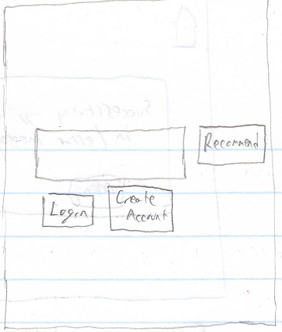

State 2.0

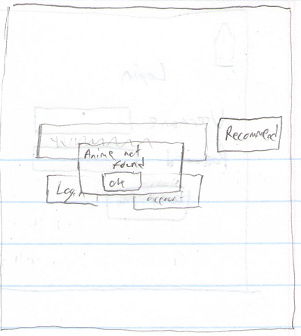

State 2.1

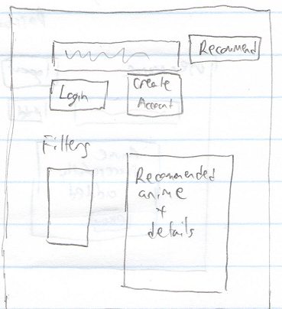

State 2.2

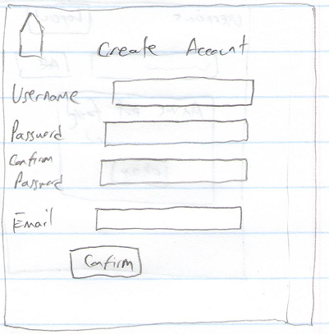

State 2.3

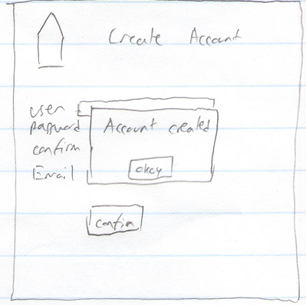

State 2.4

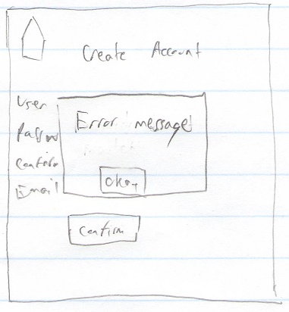

State 2.5

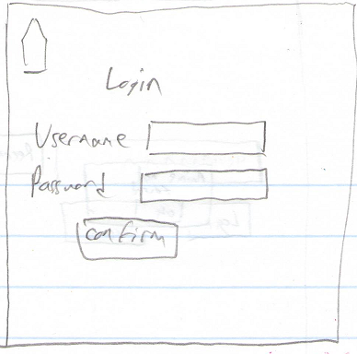

State 2.6

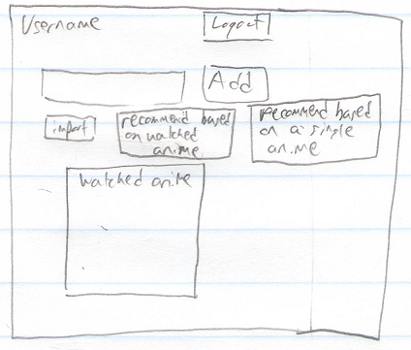

State 2.7

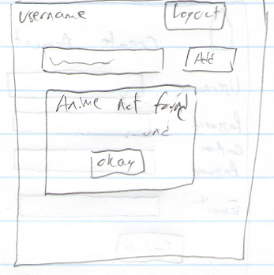

State 2.8

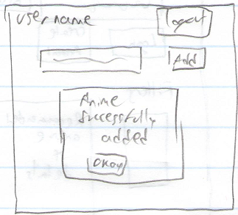

State 2.9

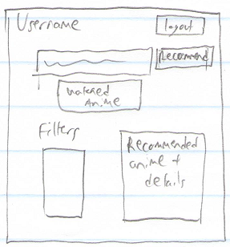

State 2.10

# Design Evaluation

## Design Decisions

The decisions behind each of these prototypes was to attempt to have a clean interface that the user would be able to use to quickly and efficiently navigate through the website. We wanted to ensure that the main page had the ability to allow one time users to use the recommendation feature and for them not to be confused when attempting to do so. Likewise we wanted users with accounts to be able to quickly and efficiently add anime to their watched list. Decisions made for each prototype are explained in each of the evaluations below.

## Prototype 1 Evaluation

Prototype 1 had a dedicated page for each feature planned for our system. This led to the user being able to understand the focus of each page and how it should be used. This was definitely a strong aspect to this prototype. However the drawback to having dedicated pages led to unnecessary navigation through many pages to do certain features, like adding to the list of watched anime from the user home page. This slowed down the efficiency of users attempting to use our system which could be a reason that users would attempt to find alternatives. A solution to this may be to cut down on the number of pages and try to have more centralized pages that allow the users to access features more easily and efficiently. The implementation of this solution was attempted with prototype 2.

## Prototype 2 Evaluation

Prototype 2 attempted to have users stick to one “home page” that stayed similar throughout their use of our system. Each page attempted to center around a textbox which users could use to add anime or get recommendations depending on the page the user was currently on. This led to a cleaner overall looking interface and an overall better experience from users shown both prototypes. A drawback from this prototype was that attempting to center the design on a central textbox created the situation where users could easily confuse the functionalities of the buttons below the textbox to be related to the functionality of the textbox itself. A solution to this may be to place the buttons further away from the textbox such that there is no confusion about what the buttons do. This solution can and will be implemented in the final product as the distance between the textbox and the buttons below the textbox are not set in stone.

## Prototype choice

We have decided to use prototype 2 for our project. This is largely due to the positive response from users that were shown both prototypes. It is also an overall cleaner prototype which cuts down total navigation done by the user when compared with prototype 1. The main complaint with the use of prototype 2 was listed above, however we intend to fix it for the final product by simply increasing the distance of the buttons below the textbox.